The Pharisee and the Tax Collector
“Loot” Bag
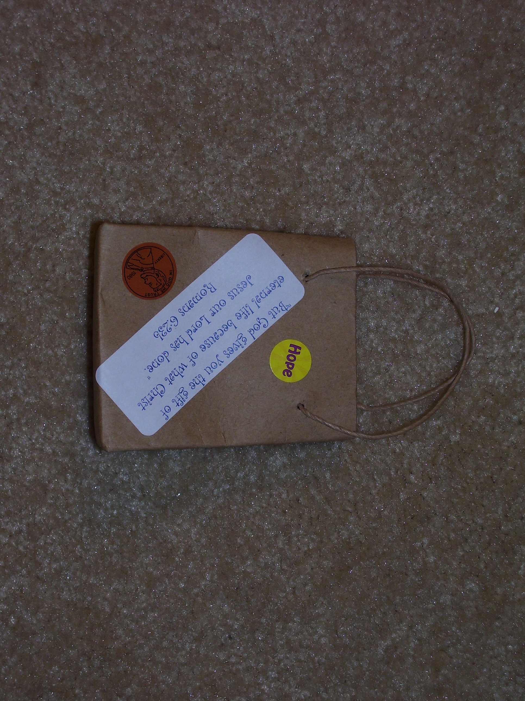

Directions:
- Choose a brown bag (www.orientaltrading.com #48/5215)
- Apply Main Point sticker on one side of the bag and the Key Bible Verse sticker on the other
- Add one coin sticker to front of bag and one coin sticker to the back
- Decorate with stickers, markers or gel pens
- Add 2 coins to inside of bag (www.orientaltrading.com #39/1100)

